

Name:

Usama Iftikhar Butt

Roll No.:

17114119-005

Section:

CS-17-A

Assignment:

Shell Script Programs

Submitted to:

Mr. Zulfiqar Ali

1.Write a shell script program that reads a number from the user and tells whether it is even or odd using if-else structure.

Code

#!/bin/bash

read -p "Enter a Number : " Number

if [ $((Number % 2)) -eq 0 ]

then

echo "The Number is Even."

else

echo "The Number is Odd."

fi

Output:

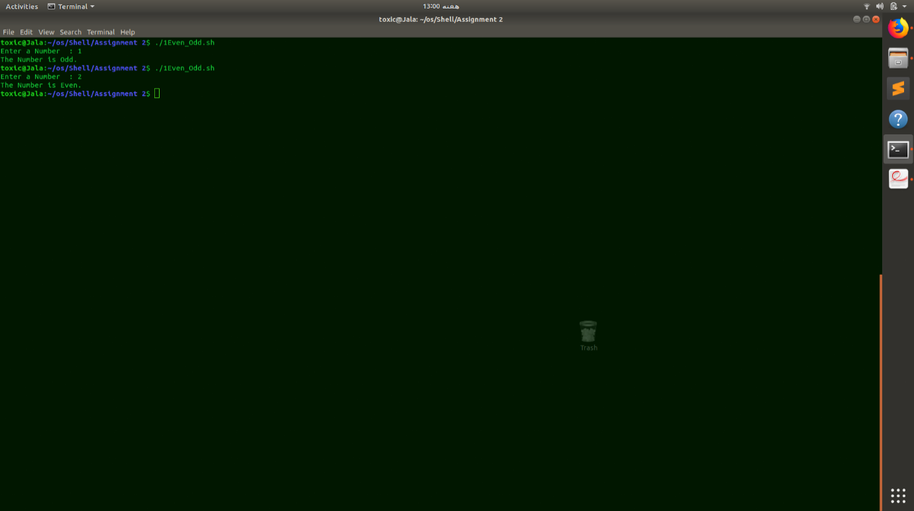

2. Write a shell script program that inputs a year and finds whether it is a leap year or not using if-else structure.

Code:

#!/bin/bash

read -p "Enter a year : " Year

if [ $((Year % 4)) -eq 0 ]

then

if [ $((Year % 100)) -eq 0 ]

then

if [ $((Year % 400)) -eq 0 ]

then

echo "This is a LEAP Year."

else

echo "This is not a leap Year"

fi

else

echo "This is a LEAP Year."

fi

else

echo "This is not Leap Year."

fi

Output:

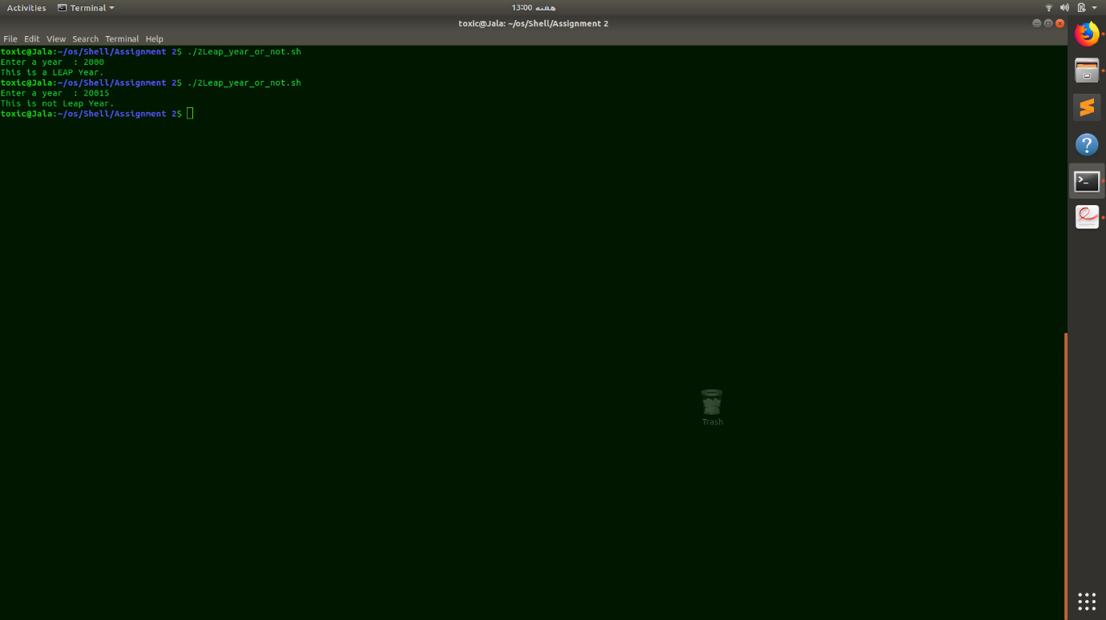

3. Write a shell script program that inputs salary and scale. It adds 50% bonus to the salary if the scale is greater than 15. It adds 25% bonus to the salary if the scale is 15 or less and then display the total salary.

Code:

#!/bin/bash

read -p "Enter your Salary : " Salary

read -p "Enter your Scale : " Scale

if [ $Scale -gt 15 ]

then

echo "Your total Salary with Bonus is : " $((Salary + Salary/100 \* 50))

else

echo "Your total Salary with Bonus is : " $((Salary + Salary/100 \* 25))

fi

Output:

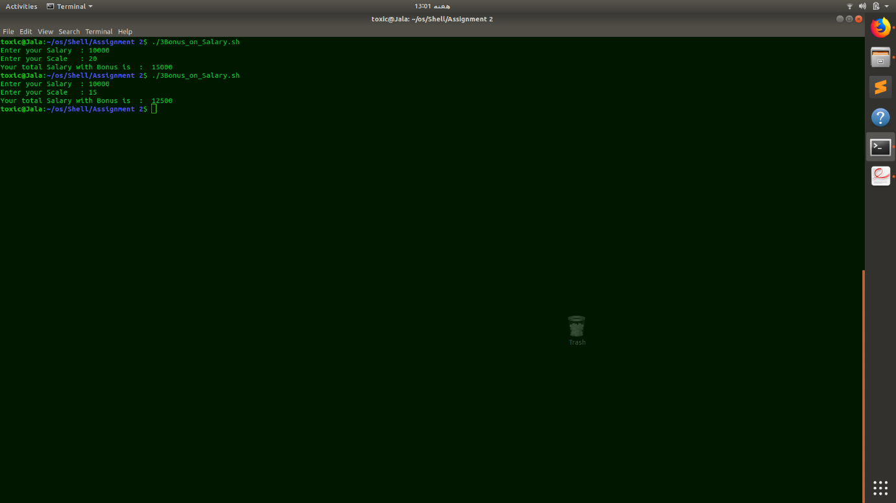

4. Write a program that inputs an alphabet from the user and tells whether it is a vowel or a consonant using switch structure. (lower and upper case inputs should also be managed properly).

Code:

#!/bin/bash

read -p "Enter an Alphabet : " Alphabet

case $Alphabet in

a) echo "$Alphabet is an Vowel." ;;

e) echo "$Alphabet is an Vowel." ;;

i) echo "$Alphabet is an Vowel." ;;

o) echo "$Alphabet is an Vowel." ;;

u) echo "$Alphabet is an Vowel." ;;

A) echo "$Alphabet is an Vowel." ;;

E) echo "$Alphabet is an Vowel." ;;

I) echo "$Alphabet is an Vowel." ;;

O) echo "$Alphabet is an Vowel." ;;

U) echo "$Alphabet is an Vowel." ;;

[0-9]\*) echo "Invalid input." ;;

\*) echo "$Alphabet is an Consonent." ;;

esac

Output:

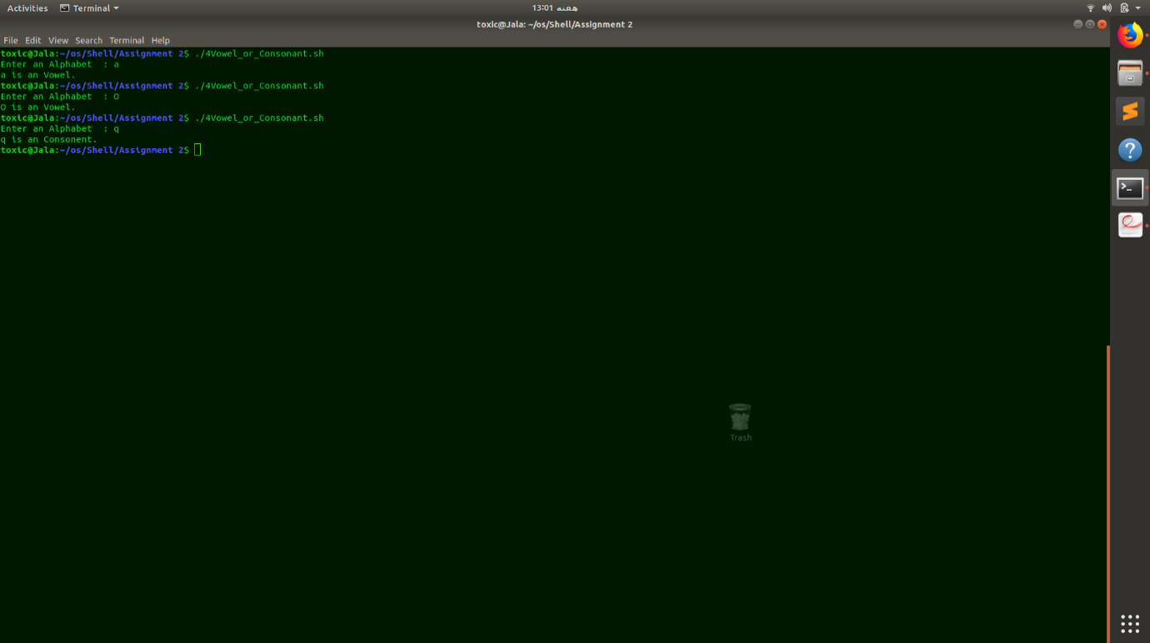

5. Write a program that inputs two numbers from the user. Then ask the user enter his choice of operation. 1 for addition, 2 for subtraction, 3 for multiplication and 4 for division. Store this choice from user in a variable. Then the screen should be clear after the user enters his choice and display only the specific operation result on the screen.

Code:

#!/bin/bash

read -p "Enter first number : " a

read -p "Enter second number : " b

echo "Enter the Option number."

echo " 1) Addition"

echo " 2) Subraction"

echo " 3) Multiplication"

echo " 4) Divition"

echo ""

read -p "Enter Choice : " Choice

clear

case $Choice in

1) echo "The Addition is : $((a + b))" ;;

2) echo "The Subtraction is : $((a - b))" ;;

3) echo "The Multiplication is : $((a \* b))" ;;

4) echo "The Division is : $((a / b))" ;;

\*) echo "Invalid choice" ;;

esac

Output:

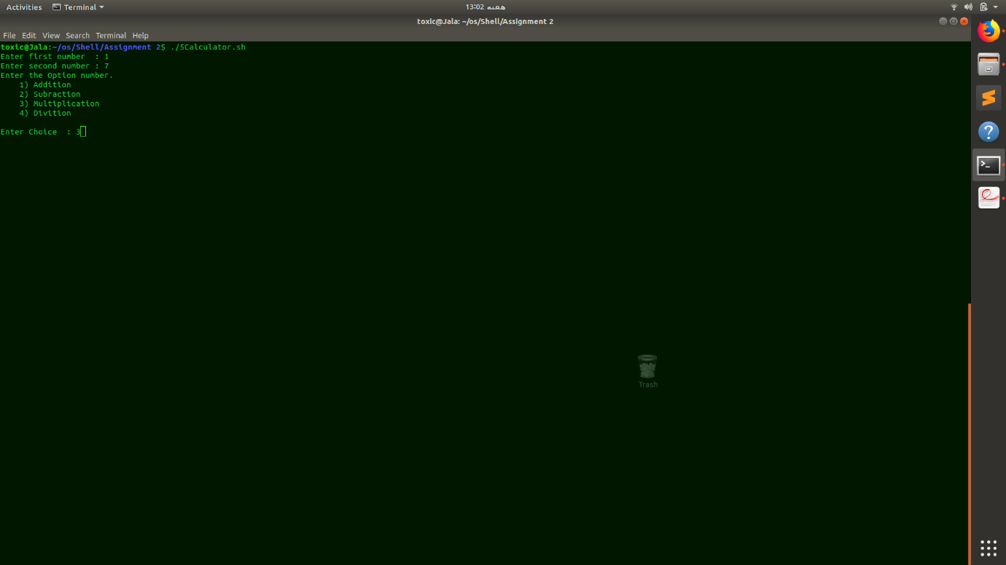 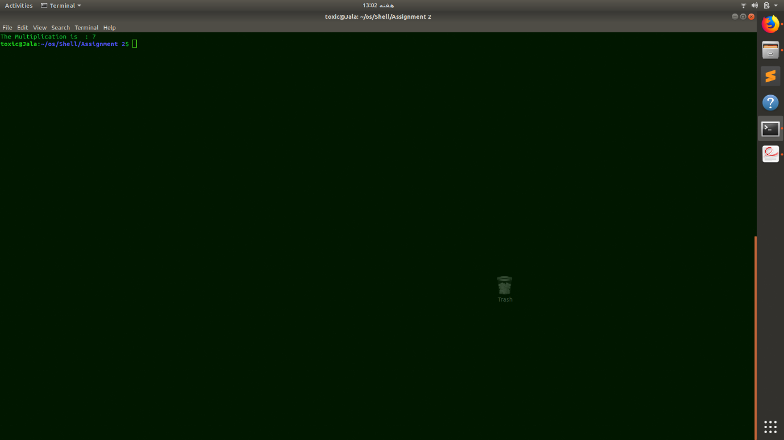

6. Write a program that gets a three-digit number from the user and display it in reverse order. For example, if the user enters 123, it displays 321.

Code:

#!/bin/bash

read -p "Enter an three digit Number : " Number

c=$((Number % 10))

Number=$((Number / 10))

b=$((Number % 10))

Number=$((Number / 10))

Number=$((c\*100 + b\*10 + Number))

echo "The entered Number in Reverse order is : $Number"

Output:

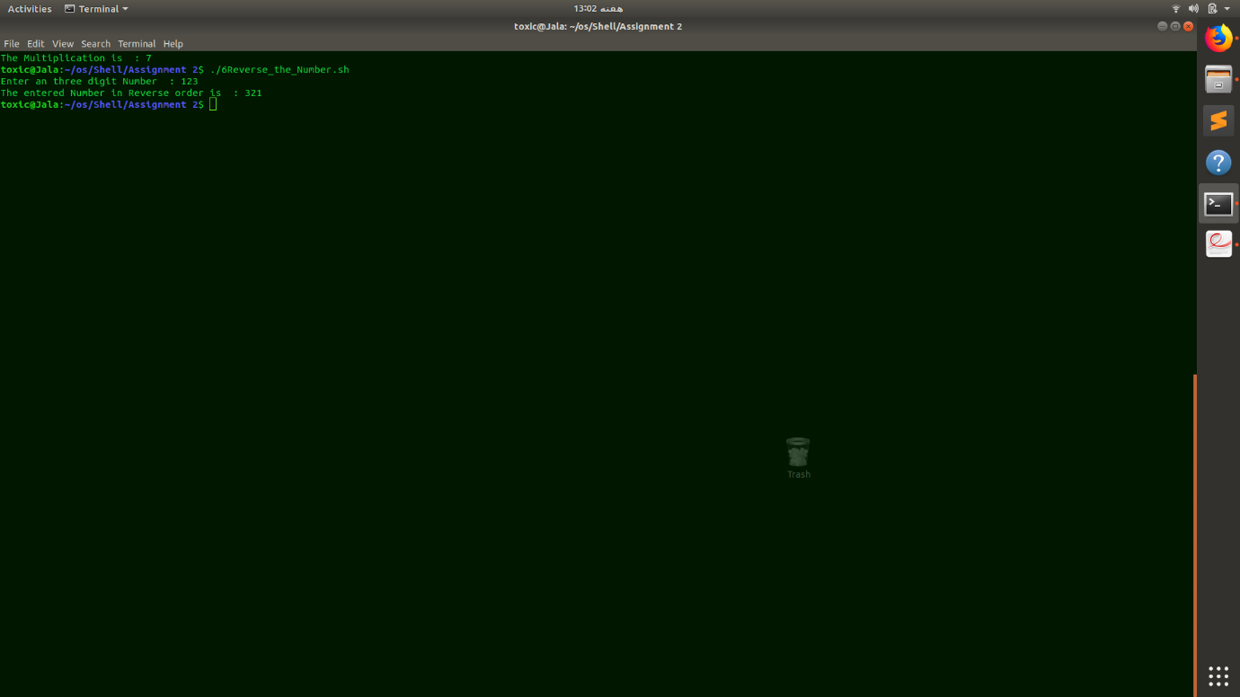

7. Take 10 integer inputs from user and store them in an array. Again ask user to give a number. Now, tell user whether that number is present in array or not.

Code:

#!/bin/bash

for i in 0 1 2 3 4 5 6 7 8 9

do

read -p "Enter an Number : " arr[i]

done

read -p "Enter an Number to Search in Array : " n

checker=0

for i in 0 1 2 3 4 5 6 7 8 9

do

if [ ${arr[i]} -eq $n ]

then

echo "Number found at $i index."

checker=$((checker+1))

fi

done

if [ $checker -eq 0 ]

then

echo "Number not Found."

fi

Output:

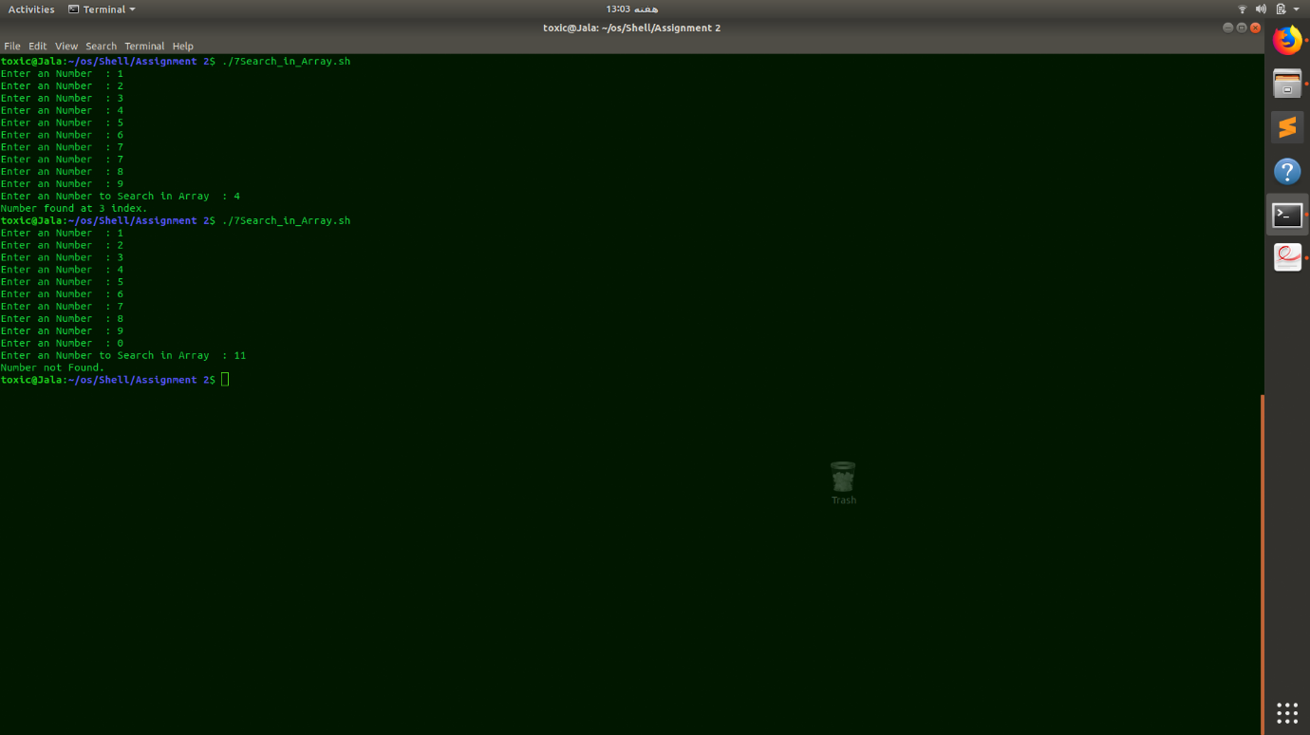 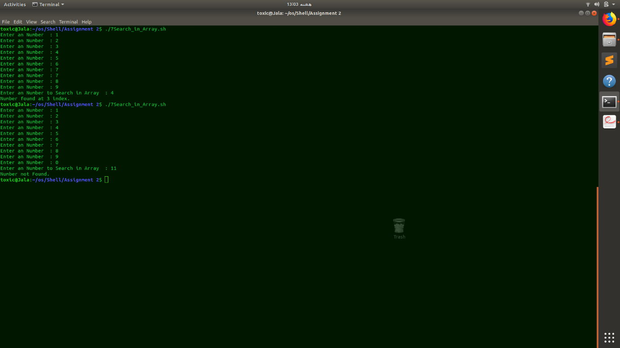

8. Take 10 integer inputs from user and store them in an array. Now calculate the sum and product of all the elements present in the array and display the results.

Code:

#!/bin/bash

for i in 0 1 2 3 4 5 6 7 8 9

do

read -p "Enter an Number : " arr[i]

done

Sum=0

Product=1

for i in 0 1 2 3 4 5 6 7 8 9

do

Sum=$((Sum + arr[i]))

Product=$((Product\*arr[i]))

done

echo "The Sum of Array is : $Sum"

echo "The Product of Array is : $Product"

Output:

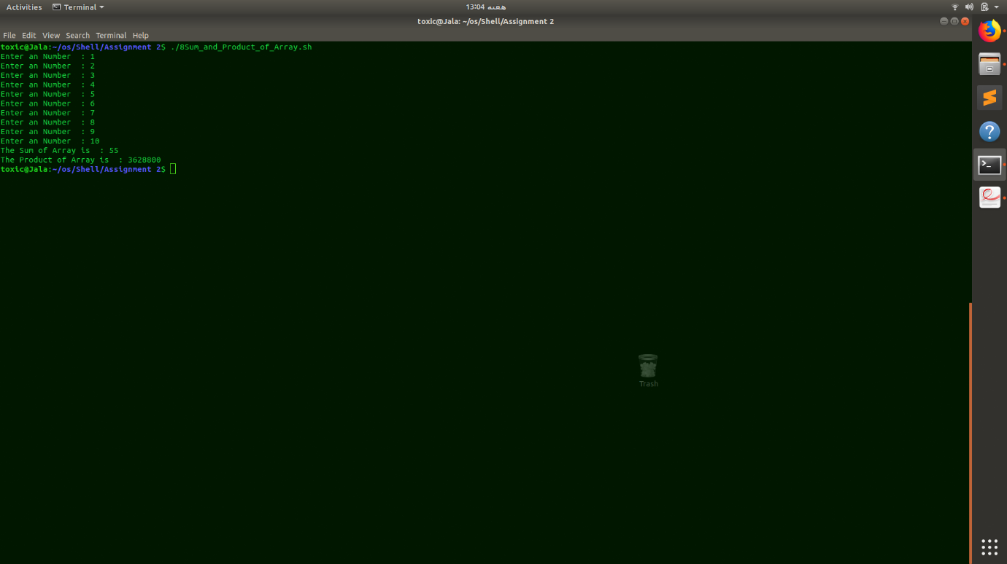

1. Take 10 integer inputs from user and store them in an array. Now find the maximum and minimum number in the array.

Code:

#!/bin/bash

for i in 0 1 2 3 4 5 6 7 8 9

do

read -p "Enter an Number : " arr[i]

done

Min=${arr[0]}

Max=${arr[0]}

for i in 0 1 2 3 4 5 6 7 8 9

do

if [ ${arr[i]} -lt $Min ]

then

Min=${arr[i]}

elif [ ${arr[i]} -gt $Max ]

then

Max=${arr[i]}

fi

done

echo "Smallest number in Array : $Min"

echo "Greatest number in Array : $Max"

Output:

